Local History
Here follows, the reproduction of a book: Edingale - a Parish in Perspective
Written by Carmel and Anthony Mason, printed and distributed to celebrate the Golden Jubilee of Her Majesty Queen Elizabeth II - Revised edition 2008.
Printing funded by Edingale Parish Council.
This book uses illustrations by Helen Pilgrim, some of which also appear in the commemorative print distributed at the same time as this publication.
The chapters are all provided in pdf format, and file size is indicated
MAPS
Oakley Tithe Map |  | Croxall Tithe Map
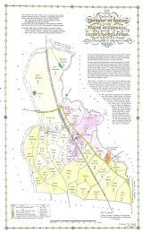  Civil Parish Map  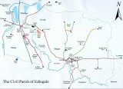 |  | 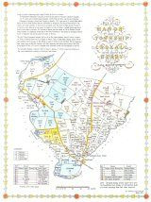
 |  | Inclosure Map
 |  | 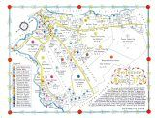
Index:
- Front Cover - 41kb
- Introduction - 113kb
- Chapter 1 - 0.23Mb
- Chapter 2 - 39kb
- Chapter 3 - 0.68Mb
- Chapter 4 - 1.45Mb
- Chapter 5 - 78Kb
- Chapter 6 - 0.68Mb
- Chapter 7 - 2.13Mb
- Chapter 8 - 0.38Mb
- Chapter 9 - 1.23Mb
- Appendix 1 - 18kb
- Appendix 2 - 13kb
- Bibliography - 4kb
- Edingale - Poem - 3kb
The maps on the right, will click through to an enlarged version that you can read more clearly.
The above book and the associated maps are reproduced by kind permission of the authors and Edingale Parish Council, who retain copyright to the works. The Public Rights of Way map is reproduced under licence from Staffordshire County Council. You may download for private or educational use, but must not be used commercially, or for personal gain.

