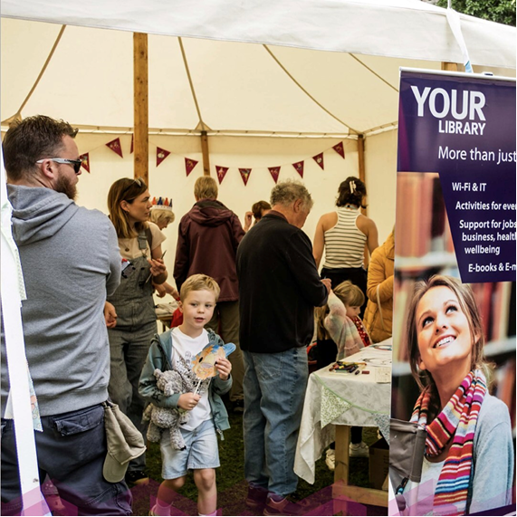

## **Discover Staffordshire’s Future at Our Communities & Culture Roadshows!**

Join the conversation, shape your community! The way we live, connect, and work together in Staffordshire is about to reach new heights. With the launch of our new Communities and Cultural Strategy, Staffordshire County Council is hitting the road to bring this exciting vision to you! Come along to one of our Communities & Culture Roadshows to hear about the positive changes that are coming your way and how you can be a part of it all.

Our Communities Strategy was designed with the people of Staffordshire, for the people of Staffordshire. It focuses on making our communities safer, more connected, and more inclusive places to live and enjoy. But for it to truly succeed, we need your voice, ideas, and energy to shape its impact. The roadshows are a great opportunity for you to learn what’s happening and to share your own insights on what makes your community thrive.

**Why Attend a Roadshow?**

Our roadshows are all about listening to you. They’re casual, welcoming events where you can pop by to:

* Hear about exciting community initiatives and discover how the Communities Strategy and Cultural Strategy is bringing real change across Staffordshire.
* Learn how you can make a difference – Find out about local projects, volunteer opportunities, and simple ways to get involved in shaping your neighbourhood.
* Meet council representatives and fellow residents – This is your chance to speak directly with the people working behind the scenes, ask questions, and even connect with others who share a passion for making Staffordshire a great place to live.

So, if you’ve ever thought, “I wish I could see real change in my area,” this is your chance to make that happen! Join us at a roadshow near you and be part of the conversation that will help shape the future of our communities.

**Roadshow Dates & Locations**

Here’s where you can find us:

* Cannock Chase Visitor Centre, Marquis Drive Date: 1 November Time: 10am - 12pm
* Tamworth Library Date: 5 November Time: 10am - 12pm
* Lichfield Library Date: 5 November Time: 2pm - 4pm
* Newcastle Library Date: 6 November Time: 10am - 12pm
* Leek Library Date: 17 December Time: 2pm - 4pm
* Burton Library – Date and time to be confirmed
* Staffordshire History Centre – Date and time to be confirmed

To stay updated on the Communities & Culture Roadshows and to find more details as dates are confirmed, please visit: [www.staffordshire.gov.uk/communities](https://links-1.govdelivery.com/CL0/http:%2F%2Fwww.staffordshire.gov.uk%2Fcommunities%3Futm_medium=govdelivery%26utm_source=email/1/01000192d9d4e242-8b58e1c2-4b2d-49ea-aa93-dd4f9e25f578-000000/fkPrJuQaaV0eZa-MYW67U9sgoyzzU1wp5Q2nDicveVQ=377).