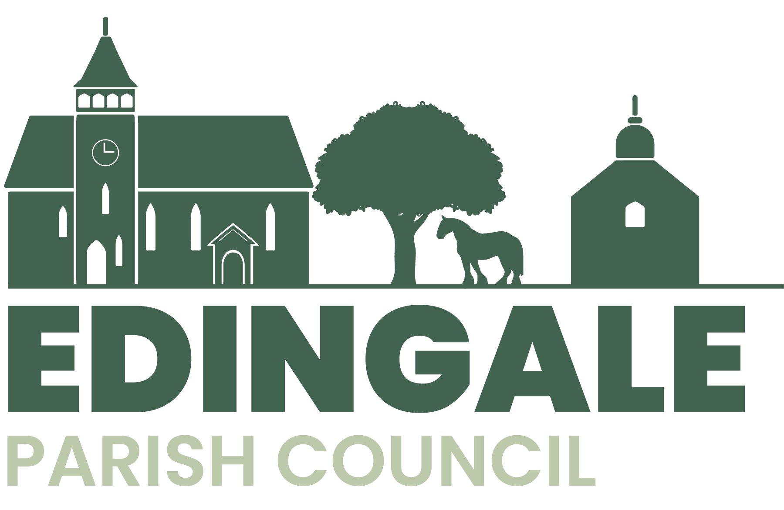
Notice of the Annual Parish Meeting 2025
Edingale Village Hall, Tuesday 13th May at 7pm
followed by the Annual Meeting of Edingale Parish Council
A G E N D A
- To approve the Minutes of the Annual Parish Meeting held on 7th May 2024.

- To receive reports from village organisations.

- To receive questions, comments and suggestions from residents.
Signed
J.Startin
Chair of Edingale Parish Council

